SPINE TANGO INFORMATION PORTFOLIO
for representatives of the medical device industry

Produced: 17 September 2021 (v1)
Updated on: 10 October 2022 (v2)

Contents
1 The Spine Tango Registry 2
2 Mission of the Spine Tango Registry 3
3 Medical Device Regulations (MDR) 2017/745 3
4 EUROSPINE Subscriber Services 4
4.1 Introduction to subscriber services 4
4.2 Subscriber Service Description 4
4.3 Service Terms and Conditions 5
4.4 Data Access and Code of Practice 5
4.5 Spine Tango Subscriber Services Order Pack 6
5 Application Provider 6
6 Contact 6
7 APPENDICES 7

The Spine Tango Registry

Spine Tango is an international web-based registry that collects and evaluates data on treatment effectiveness, patient safety and best practice for quality assurance and research on surgical and non-surgical spinal treatments.

The registry is continually developing to provide valuable services to MedTech companies.

Key aspects:

- Experience: The registry was established in 2002 and, thus, has a history of 20 years.

- Funding: By EUROSPINE.

- Data: About 800,000 forms have been documented, including over 150,000 surgeries with over 570,000 patient outcome forms from 17 countries from Europe and non-European countries such as the USA, Australia, and Iraq.

- Common language: The registry is constantly engaged in the standardisation of documentation of spinal treatments, definitions, outcome parameters, and, consequently, of spinal care.

- Spinal treatments: Standard documentation forms for surgical and conservative therapies are designed to enable structured documentation of the whole spectrum of spinal treatments.

- National registries: The registry template is used by the Swiss specialist (Spine, Neurosurgery, Orthopaedics) societies as a Swiss Implant Registry “SIRIS Spine”. Some other societies have demonstrated their interests as well.

- Implant database: A large pan-European implant library has been developed. It is regularly updated by MedTech companies and is under continual development. Today, almost 200,000 implantable products are specified in the library, enabling accurate implant documentation and reporting.

- Recording implant use: The surgical forms include a section for implant details to be recorded for each case. Devices recorded in the implant library are available to the end hospital users to add to the surgical forms. This includes a barcode scan function for efficiency. Recording implant use allows for post market surveillance tracking of implant performance.

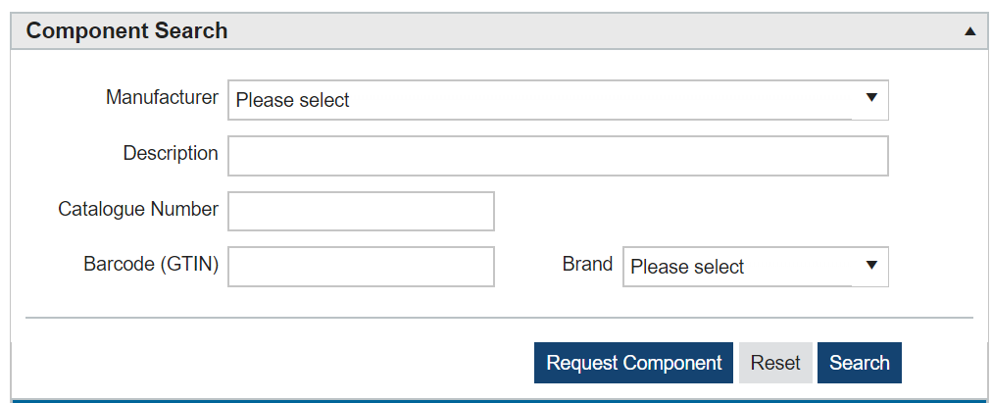

- Adding implants to the component library: Contributing medical departments can request missing implants which do not exist in the library. Existing or new innovative implants being sold in Europe will be requested to be added. This ensures contributing medical departments using these implants can continue to record their use. The below embedded upload template can be utilised by MedTech companies to add implants to the registry.

- Implant classification architecture: Spine Tango, in partnership with MedTech companies, have agreed and developed an implant classification architecture (Appendix 1) which specifies the attributes which are collected for implantable devices. The purpose of requesting that medical device companies describe their implants is to enhance the reporting services available to industry and other stakeholders. For example, by classifying devices into their respective categories the reporting services can support similar device comparisons to support “State of the Art” requirements. A combination of the device dataset and the hospital datasets enriches the data.

- High level process flow diagram: The following flow diagram demonstrates the process for the provision of manufacturer implant data, the assignment of implant data against a surgical procedure by a hospital, and the analysis outputs available to subscribed manufacturers.

Mission of the Spine Tango Registry

- Improving spine care and patient safety through recording and monitoring of patient outcomes after treatment of various spinal pathologies.
- Providing performance benchmarking and developing a collective evidence base of treatment effectiveness, patient safety and best practice based on real life data.

Medical Device Regulations (MDR) 2017/745

The MDR had a transitional period of four years and came fully into force on 26 May 2021. The MDR means that post-market surveillance (PMS) is now more rigorous. PMS has to be a part of the new technical documentation for every product and it is required to be pro-active. This means MedTech companies will need to provide regular feedback post product implantation. The aim is to drive up quality and to catch potential issues before they escalate.

Medical devices in the EU have to undergo a conformity assessment to demonstrate that they meet legal requirements to ensure they are safe and perform as intended. Manufacturers can place a CE (Conformité Européenne) mark on a medical device once it has passed a conformity assessment.

EUROSPINE offers PMS reporting services to subscribing organisations which aim to support medical device regulations.

EUROSPINE Subscriber Services

Introduction to subscriber services

EUROSPINE recognises the medical technology industry as a key registry stakeholder, and the need for implant suppliers to have access to a range of services based upon EUROSPINE data collected within the Spine Tango Registry. The purpose is to evidence product performance through post market surveillance reporting to meet regulatory requirements.

To date, Spine Tango has been exclusively funded by EUROSPINE. However, to support a long-term sustainable model for the running and development of the Spine Tango Registry, EUROSPINE has developed several pay-for-service subscriptions to increase registry funding channels. Subscriptions are renewed on an annual basis and are contracted through EUROSPINE under Swiss law.

Subscriber Service Description

Spine Tango Annual Subscription / Core Service: This is the base service offering to industry. It is aimed at servicing individual bespoke requests and provides a facility for industry to liaise with the Spine Tango Registry Team in the development and specification of Study Protocols for interrogation of retrospective data contained within the Spine Tango database. As part of this service, the Spine Tango Registry Team will:

- Work with the Subscriber to develop a Study Protocol and advise the Subscriber on the feasibly of each request, and modifications that may be considered to enhance the quality and completeness of the output.

- Where required, liaise with any local healthcare provider to coordinate augmenting Spine Tango data with locally collected data to enhance the completeness and / or quality of any Study.

- Administer the necessary approvals for each request from the Spine Tango Committee.

- Undertake bespoke report development as approved by the Spine Tango Committee necessary to fulfil an approved Study Protocol (subject to additional charge).

- Spine Tango Reporting Service / Subscriber Feedback Service: This service is available to any medical device supplier with an active Spine Tango annual subscription. In addition to the Annual Subscription / Core Service, this Service also provides:

- Standardised product reports on implant volumes, activity, case mix and outcomes for each product brand (or product family where otherwise identified), refreshed on a quarterly basis.

- Aggregated summary data.

- Spine Tango Support to include liaison and coordination with local centres on data quality, data collection, and data enhancement (prospective and retrospective).

- Access to bespoke report service, providing bespoke modifications to the standard Product Reports (subject to additional charge).

- Access to bespoke patient follow-up services (subject to additional charge).

- Pricing: The following table outlines annual subscription pricing for the Spine Tango Annual Subscription / Core Service and the Spine Tango Reporting Service / Subscriber Feedback Service.

 | Annual Global Spinal Implant Sales*
 | SME | Mid Cap | Large
 | <$2m | >$2m <$10m | >$10m
Spine Tango Annual Subscription / Core Service | € 14,500 | € 14,500 | € 14,500
Spine Tango Reporting Service / Subscriber Feedback Service.  Fixed annual fee | € 0 | € 14,500 | € 32,000
Spine Tango Reporting Service / Subscriber Feedback Service.  Variable fee element | € 3.50 | € 3.50 | € 3.50
(annual procedure volume using manufacturer implants recorded in Spine Tango)
* Subscribers will be requested to self-report their category

- Spine Tango Reporting Service Sample Report: A sample of the reports available to subscribers is available to view in Appendix 2.

Service Terms and Conditions
Terms and Conditions: The service is governed by Terms and Conditions to which a subscriber agrees upon signing of the contract and acceptance of the order by EUROSPINE. The contract is between EUROSPINE and a subscribing organisation and is governed under Swiss law. A copy of the full Terms and Conditions is available to view below:

Data Access and Code of Practice
Code of Practice: The reports obtained by subscribers through the EUROSPINE services are subject to the Terms of Use and Code of Practice. EUROSPINE understands the need for MedTech companies to gain access to its data, specifically due to the industries’ statutory obligations under the EU MDR. EUROSPINE has therefore accepted the principle of Subscribers having access to the mentioned services to evidence their products’ performance for PMS purposes under the terms of this Code of Practice. The full document is available below and describes how the reports can be used.

Spine Tango Subscriber Services Order Pack

Subscriber services order pack: The documents described above and listed below together constitute the subscriber services order pack.

- Spine Tango Subscriber Services Code of Practice

- Spine Tango Subscriber Services Terms and Conditions

- Spine Tango Subscriber Services Order Form

The order pack is a contractual document which can be signed and returned by a MedTech company to subscribe to the services listed. The full order pack, which includes the Terms and Conditions, Supplier pricing and the code of practice documents is available below:

Application Provider
The Spine Tango application is delivered through NEC Software Solutions (formerly Northgate Public Services). NEC hosts several medical registries such as the National Joint Registry (NJR), which is the largest orthopaedics registry in the world with more than 3 million patient records, and the Indian Joint Registry (IJR) – all of which collect data to help clinicians, hospitals, regulators and industry deliver evidence-based treatments for patients.
For more information please visit: NEC Registries Platform

Contact

For further details please contact SupplierEnquiries@SpineTango.online or visit EUROSPINE - Implant Suppliers

APPENDICES
- Implant Classification Architecture
This appendix item describes the agreed implant architecture between EUROSPINE and MedTech companies. The purpose of classifying implants in the registry is to enhance the reporting opportunities available to MedTech companies. By classifying products into a structure, the registry is able to provide comparative reports by grouping implants into similar categories. The next few pages detail a basic classification which will evolve over time.
Spine Prosthesis Architecture
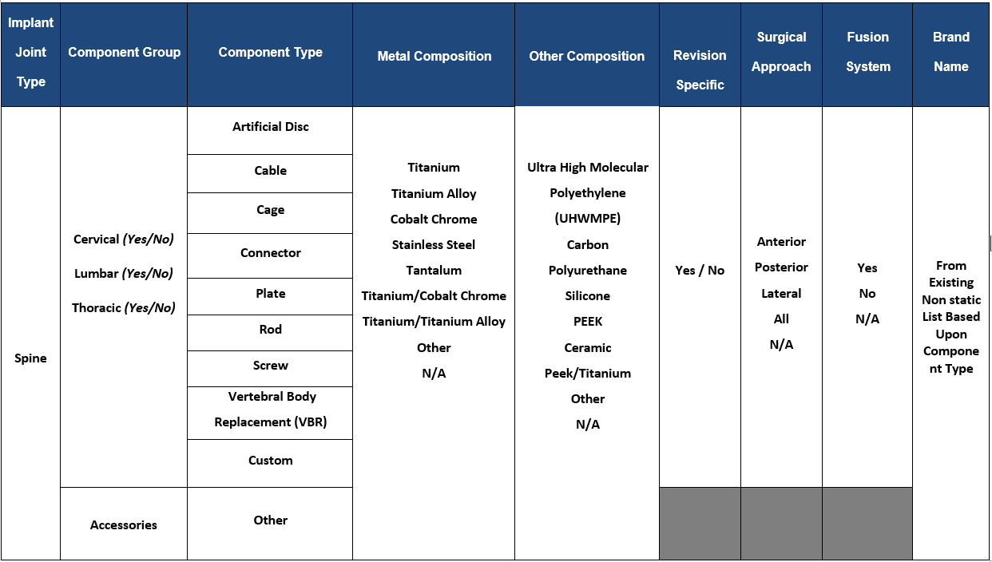

Bone Substitute Prosthesis Architecture
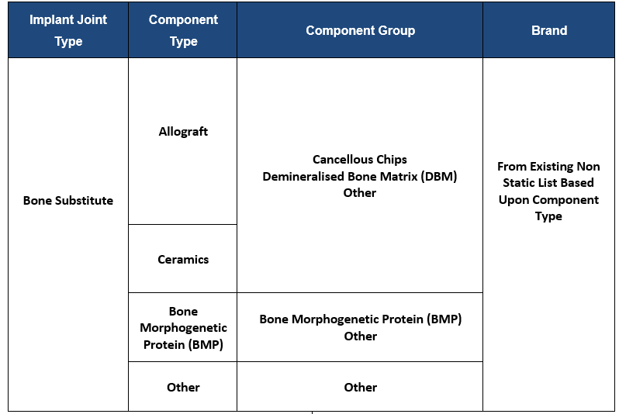

Cement (Putty) Prosthesis Architecture
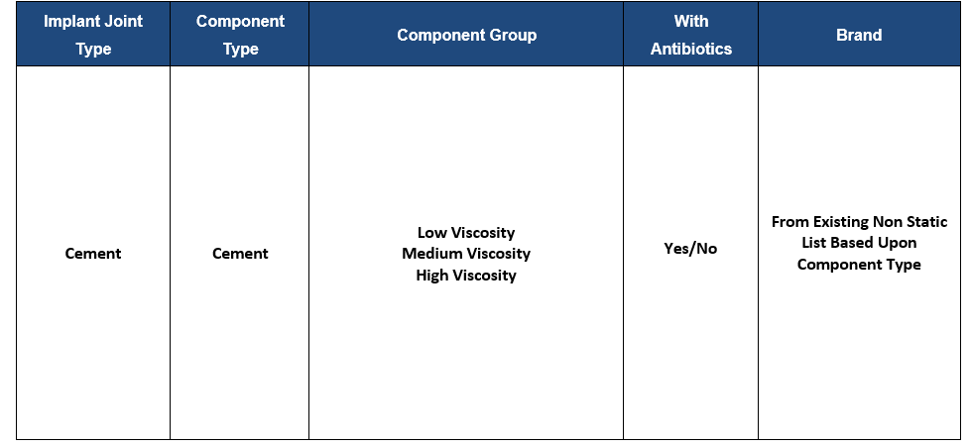

2) Sample Implant Summary Report

This appendix is an extract of a sample implant report for an example manufacturer. The benchmarking implant report is produced for subscribing companies only, for every implant brand with recorded usage in the Spine Tango registry. The reports describe how the implants are used, including anonymised patient diagnosis, treatment and outcomes (complications and preop and postop pain levels at different time points) by pathology and benchmark the results.

For further details, see the below embedded Sample Implant Report.

